13th November 2015

**YOKOHAMA Thai Subsidiary Holds Informative Event on Biodiversity Activities**

Tokyo – The Yokohama Rubber Co., Ltd., announced today that its tyre manufacturing and sales subsidiary in Thailand, Yokohama Tire Manufacturing (Thailand) Co., Ltd. (YTMT), held an event at its plant site on October 20 to inform the public about its activities to promote biodiversity inside the site. The event was attended by local community leaders, government officials, and elementary school teachers, as well as staff responsible for the CSR activities of other companies with plants in the same industrial complex and representatives from local media. The attendees received reports about the results of biodiversity monitoring on the plant site by YTMT employees as well as an explanation about plans to build a biotope to sustain and increase the diversity of life forms on the plant grounds. The visitors were also given a tour of the site by YTMT employees. The event was attended by YTMT President Toru Nakamura and members of YOKOHAMA’s CSR & Environmental Affairs Dept.

Recognizing the need to monitor the effect of its manufacturing activities on the local environment in order to contribute to creation of a better environment, YTMT began biodiversity preservation activities in September 2013. Its first step was to conduct surveys of water quality and the current state of its local environment in order to determine the optimal location for its activities. The surveys focused on (1) birds, which survive on insects and fruits in the forest and therefore are a good barometer of the richness of the local ecosystem, (2) butterflies, which are easily affected by environmental changes and therefore provide a readily available clue to the state of the natural environment in nearby areas, and (3) dragonflies, which thrive near ponds and wetlands and therefore provide insights into water quality. By capturing specimens or taking photographs of these creatures, YTMT employees built a database on the types of living creatures in the area, their food sources, habitat, and life cycles. The employees will use this data to better understand the biodiversity of YTMT’s plant site, consider means for preserving and increasing the diversity of life forms in the area, and then create a biotope that facilitates realization of this goal. The biotope is scheduled to be completed in February 2016, after which it will be used as site for continued monitoring of the environment and as a centre for learning and exchanges with members of the local community.

YOKOHAMA has established the goal of being a leading corporate sponsor of environmental protection as one of the basic policies in the Company’s “medium-term management plan: Grand Design 100 (GD100).” In addition, the Company and its subsidiaries around the world have been carrying out the YOKOHAMA Forever Forest Project since 2007, with a goal of planting 500,000 trees at domestic and overseas production sites by the YOKOHAMA’s 100th anniversary in 2017. YTMT has been an active participant in environmental protection activities, including the planting of 66,296 trees on its plant site since 2008. YTMT also held a “Salt Earth Making” event on earlier this year to help preserve the wildlife in Thailand's Khao Yai National Park.

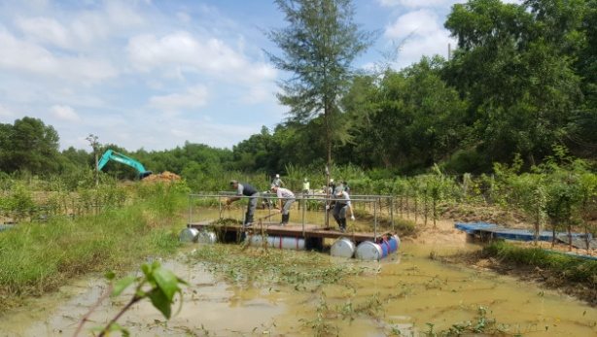

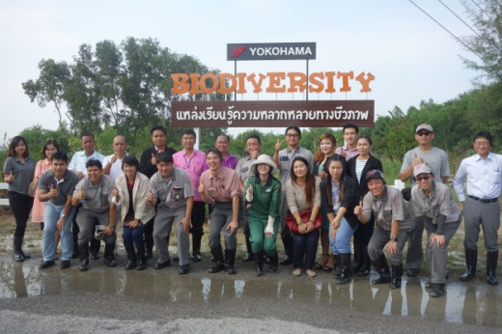

*Group photo at YTMT’s biodiversity event Biotope creation in progress*